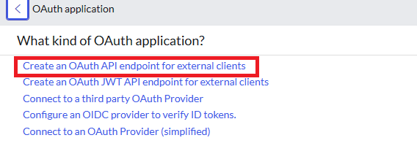

Create an authorization server from the application registries.

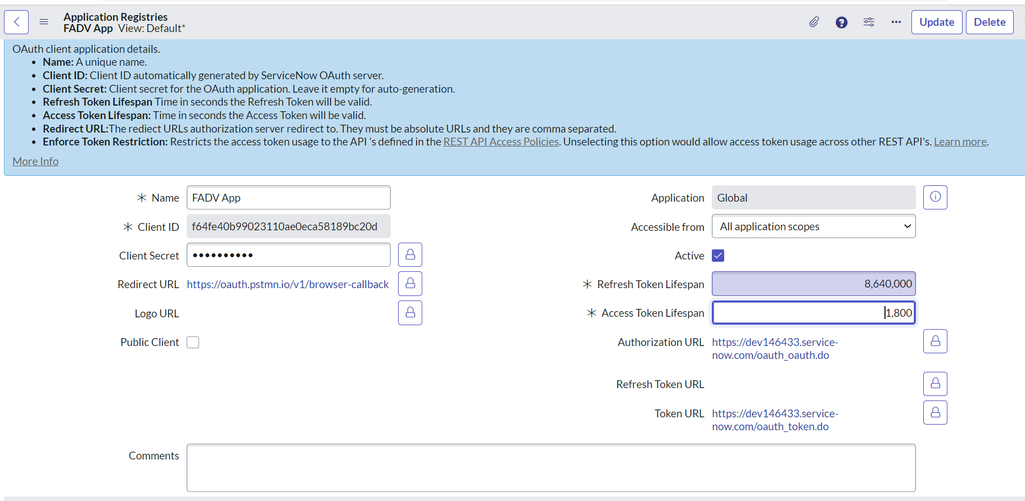

The Client ID and Client Secret will be auto generated. Give the Redirect URL where the application (in this case Servicenow)

Will redirect the user after the successful "Authorization" of the user.

Give the access token and refresh token lifespan, the authorization url and access token url.

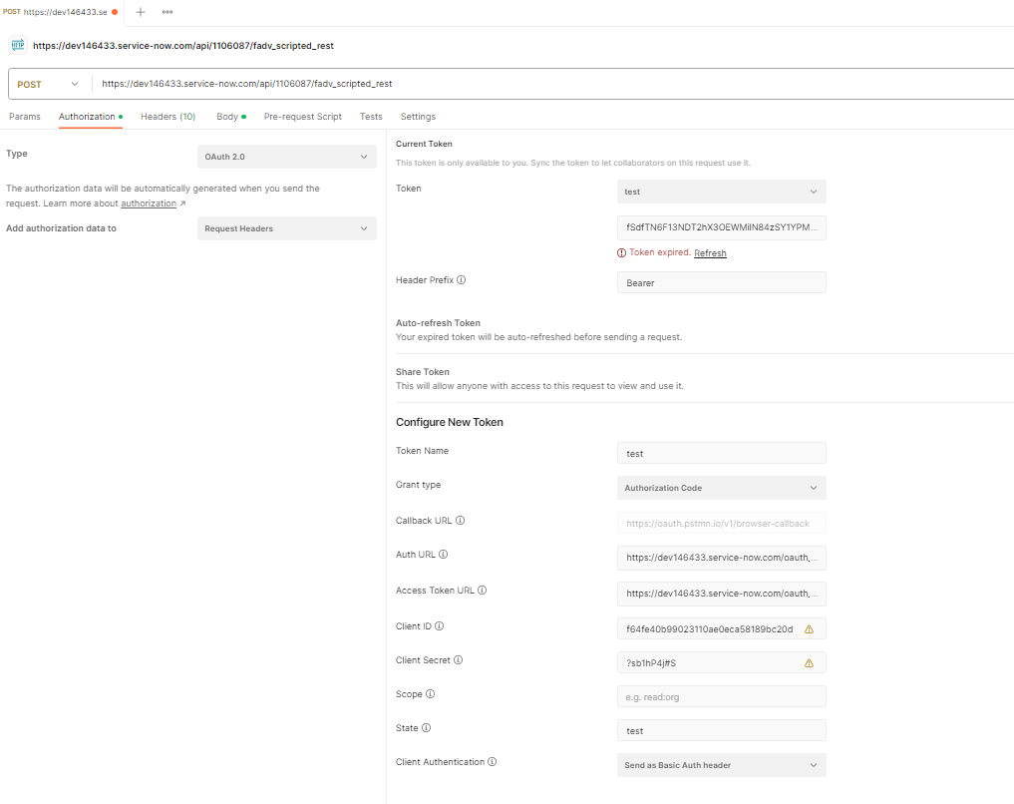

The payload which is coming from FADV can be of two types, one has an Array of Objects and the second one has an individual Object.

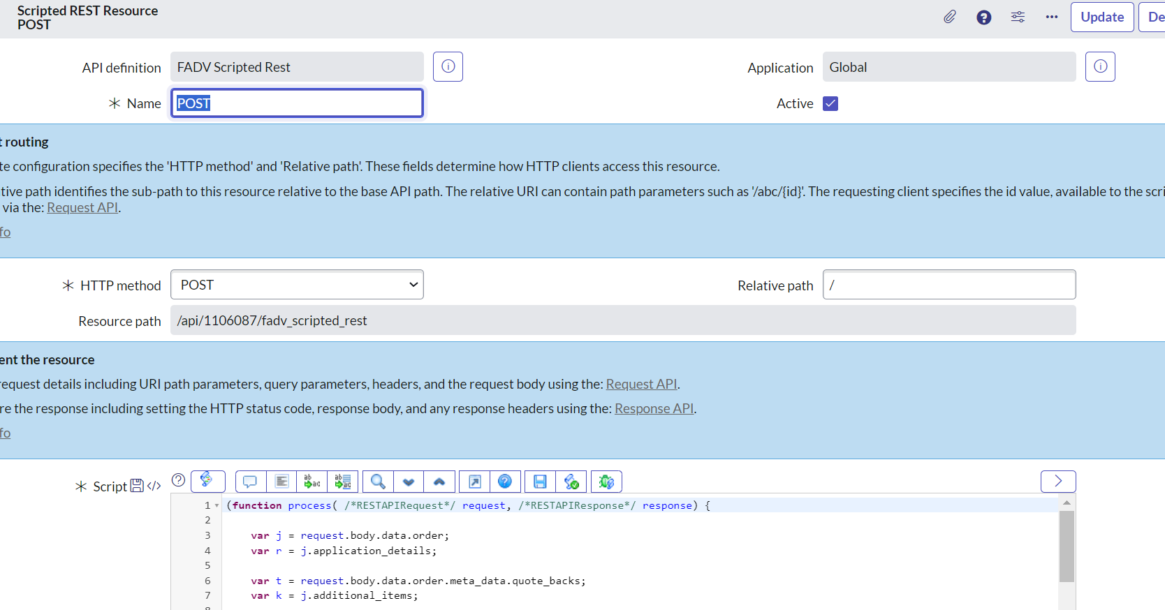

Create a POST resource in the Scripted Rest API to get the data from the FADV application.

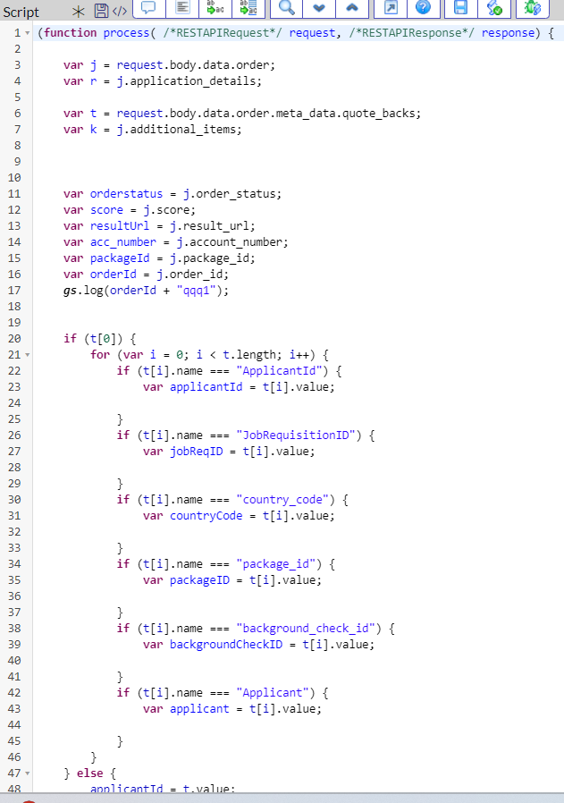

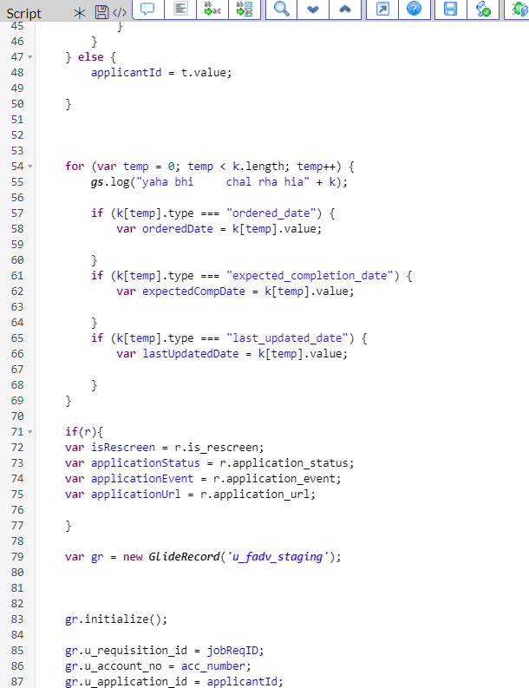

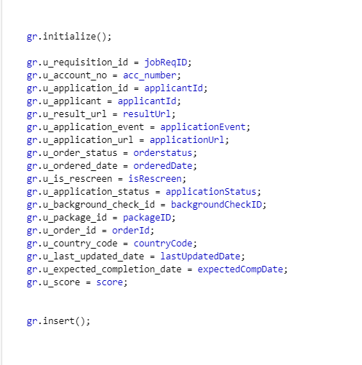

The data will first come to the staging table and then to the target table with the help of transform map (there is a related link at the bottom of the staging table list view to configure a transform map for it.